Nama : Sekar Andini Khairunnisa

NIM : L20018018

KELAS : F

1. Rangkaian yang akan di buat dan di analisa
   1. Buatlah Rangkaiannya!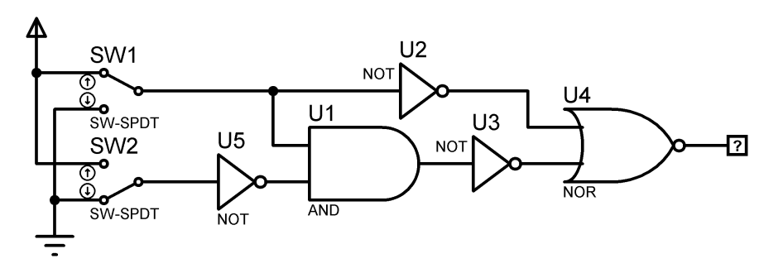
   2. Buatlah Tabel kebenarannya

|  |  |  |  |  |
| --- | --- | --- | --- | --- |
| SW1 | SW2 | X | Y | Z |
| 0 | 0 | 0 | 0 | 0 |
| 0 | 1 | 0 | 1 | 0 |
| 1 | 0 | 1 | 0 | 1 |
| 1 | 1 | 1 | 1 | 0 |
|  |  |  |  |  |

* 1. Buatlah Diagram Waktunya

|  |  |  |  |  |
| --- | --- | --- | --- | --- |
| L1 | 0 | 0 | 1 | 1 |
|  |  |  |  |
| L2 | 0 | 1 | 0 | 1 |
|  |  |  |  |
| L3 | 0 | 0 | 1 | 0 |
|  |  |  |  |

1. ( Membuat Rangkaian )Buatlah rangkaian dengan logika :

$$F=(\overline{\overline{A}∙ B}+C)+(\overline{D}∙ E)$$

